In this lab of GCP App Engine, we will create a new version of our app and we will also test traffic splitting between versions

Creating Version:-

Open same Inventory folder in vscode which we used in previous lab

Go to index.cshtml file under pages folder and add V2 in front of inventory at line 11

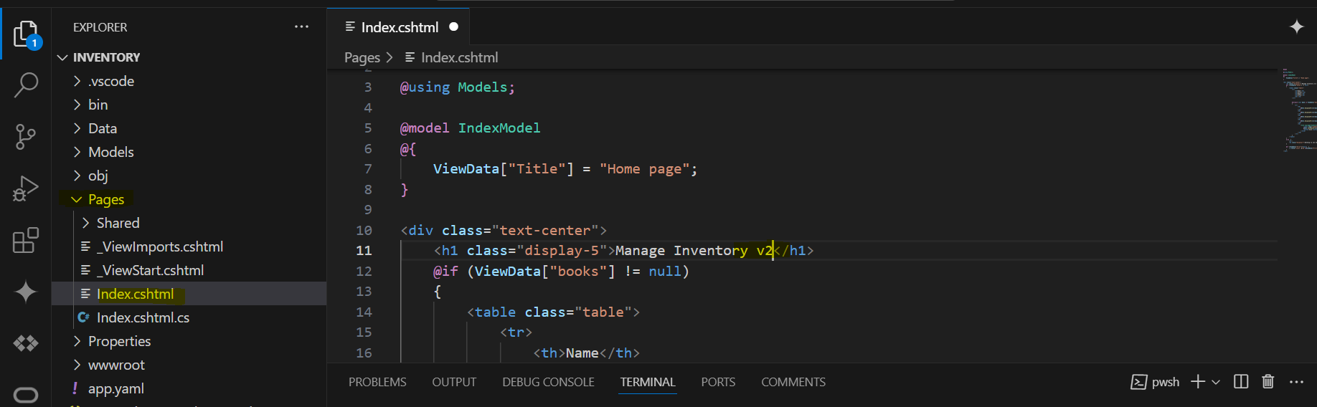

Hit F5, to test the code locally

On completion, the webpage sgould show inventory v2 now, this is to distinguish two different versions of our app

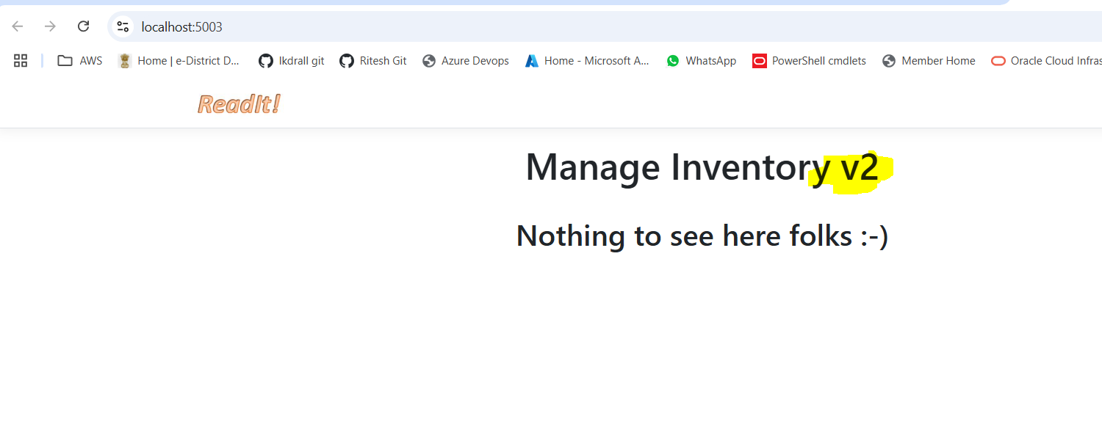

Go to GCp console, and check Inventory shows only one version

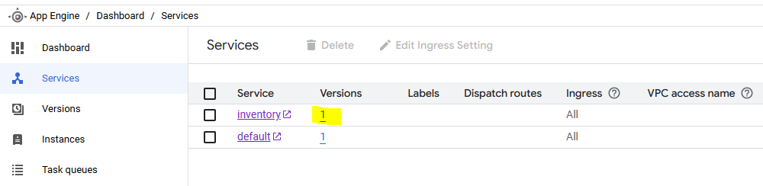

Run command gcloud app deploy -v v2 (**Make sure the service name at app.yaml name is same as we used in previous lab only change the version to v2)**

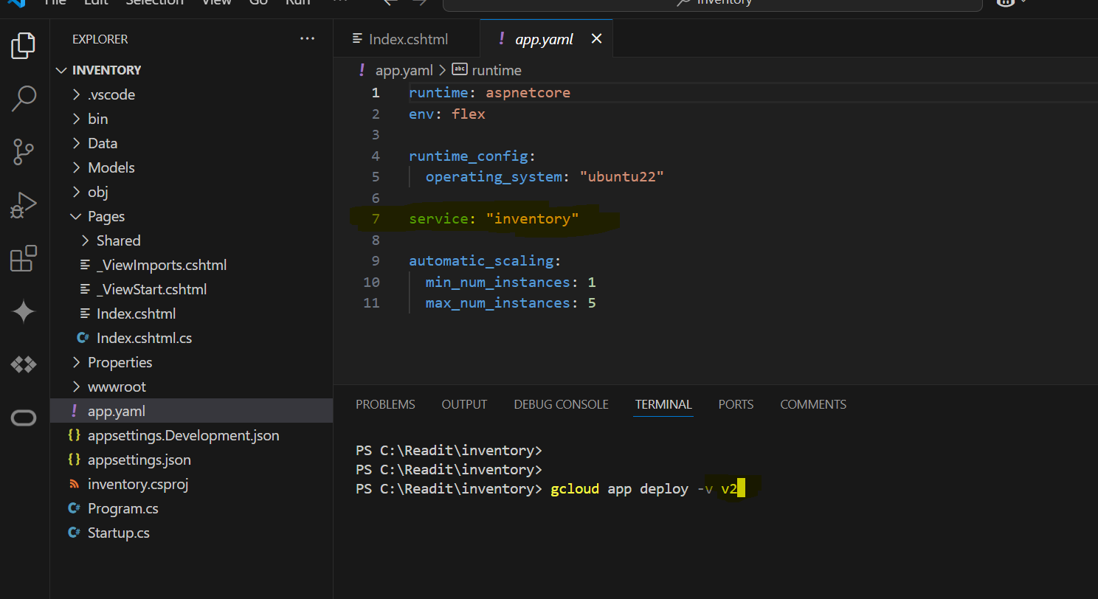

After completion, at GCP now it should show 2 versions

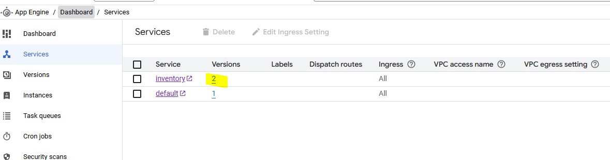

Click on service name “inventory”, now it should open v2 page. This also shows that by default, traffic is always moved to latest version.

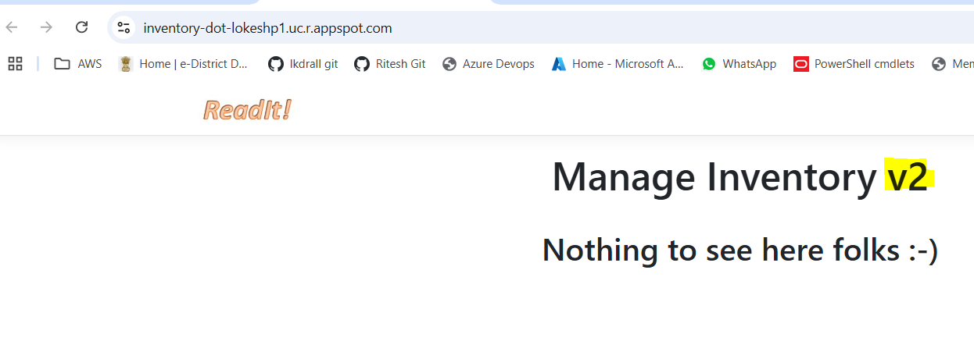

Go to versions, and there it will show that status of v2 is serving and v1 is stopped

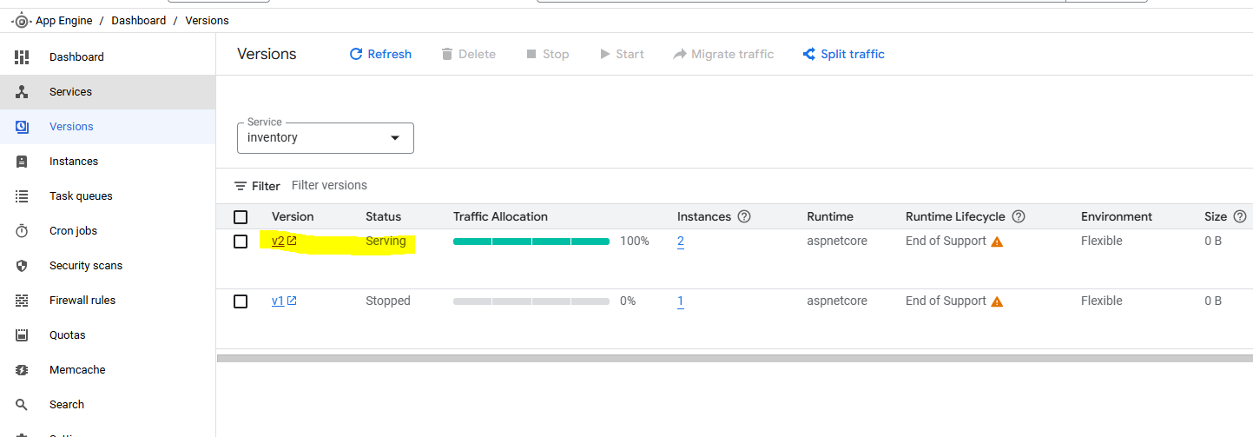

Select v1 and click start to start the version for serving

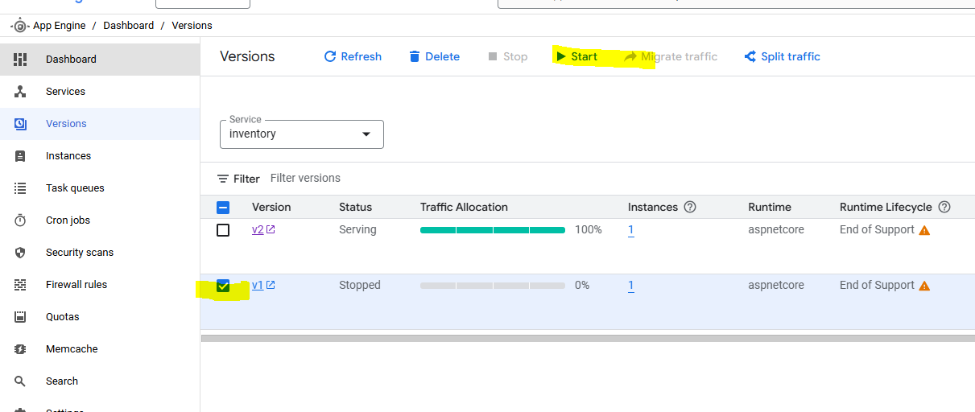

Wait for some time. And then click v1, it will open the version 1 webpage (without v2 written after inventory). Also note that the url also show the v1, but not the app name like previously which was “https://**inventory**-dot-lokeshp1.uc.r.appspot.com/”. This is because only default version shows the correct app url.

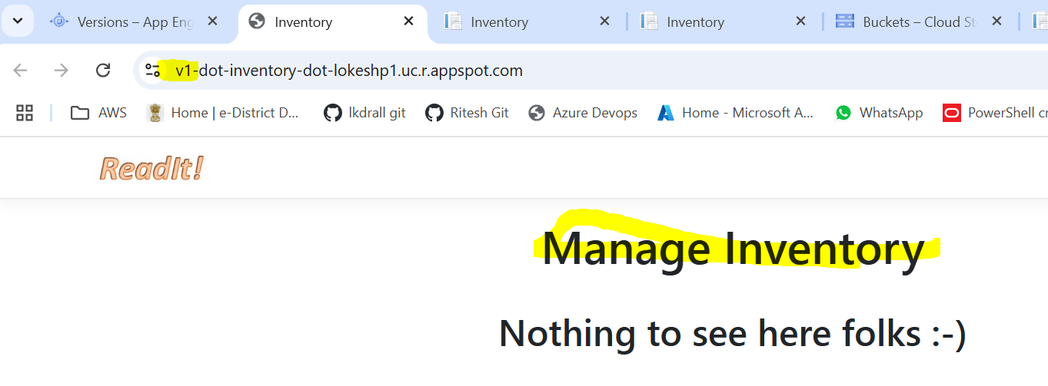

**Traffic splitting:-**

Click split traffic

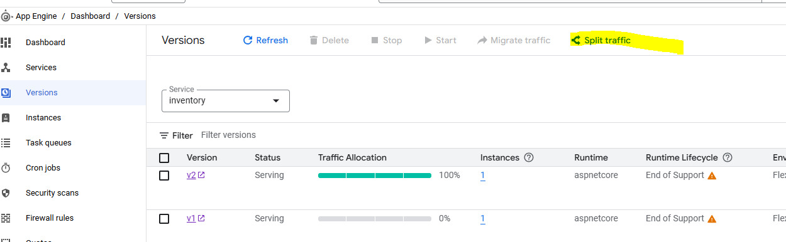

It shows 100% allocation to v2, click “Add version”

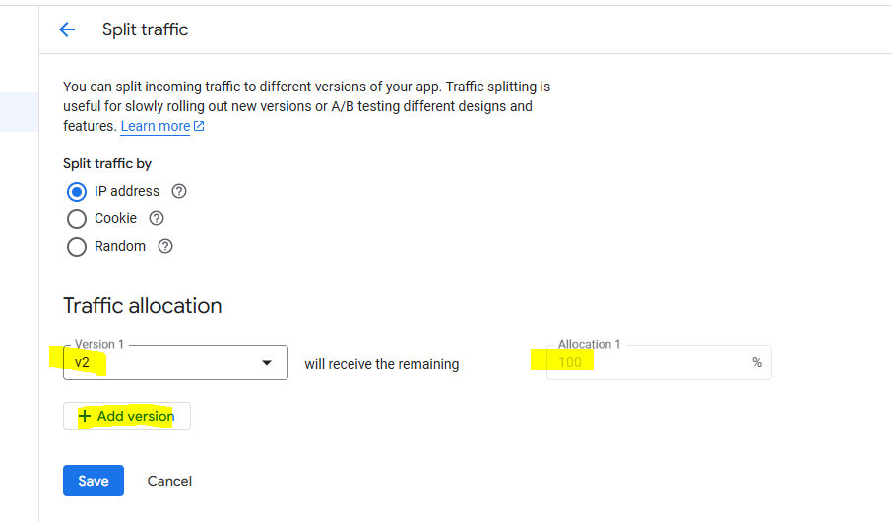

Select v1 and make splitting to 50-50. Select “Random” split traffic for lab purpose

Also note, we can use Ip address (this will route traffic from specific IP address to same version every time and if we use Cookie then that will save cookie in user browser and will use version accordingly in future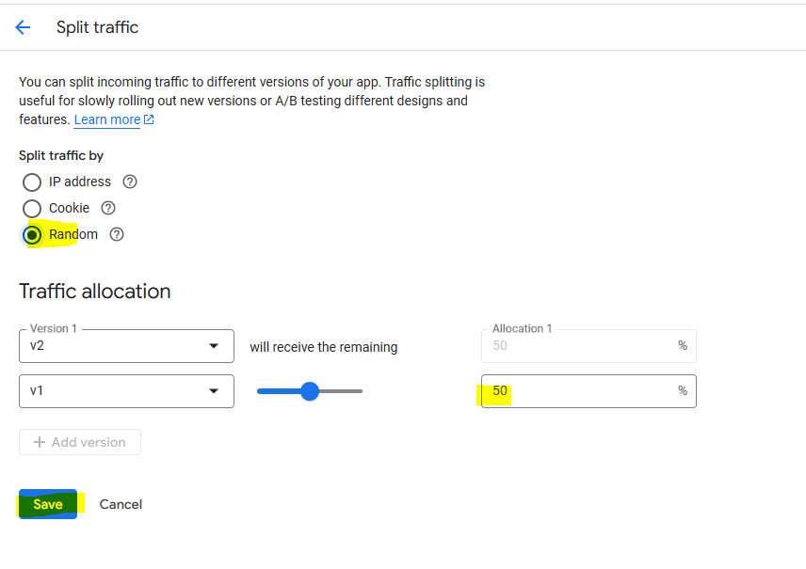

Now go back to Services page and open url by clicking service name, this will open the app page again. Try refreshing page again and again and it will some time open v1 and sometime v2 but url will remain same

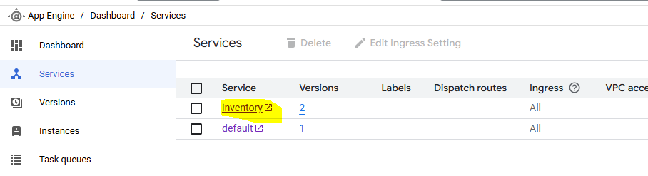

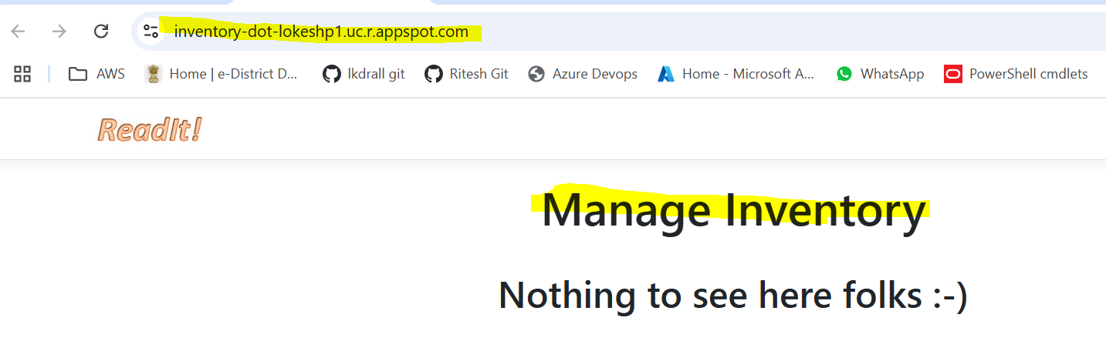

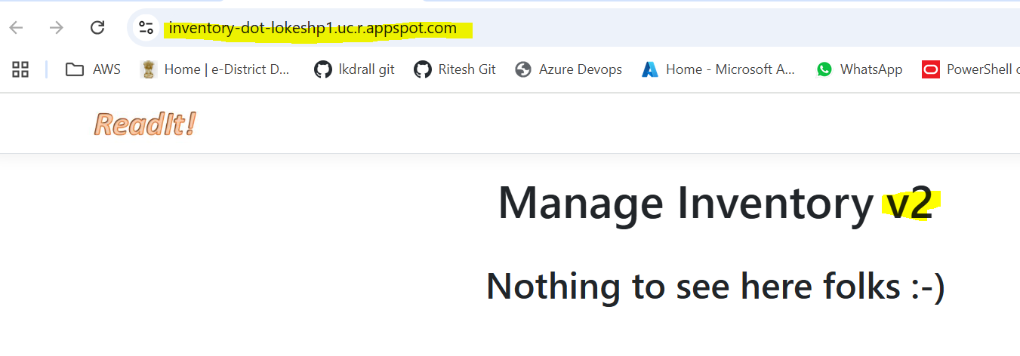

Once lab is completed, make sure to delete the traffic splitting by removing v1

